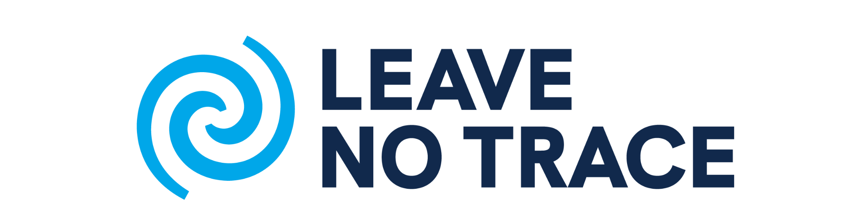

ACTION PLAN WORKSHEET

NAME DATE

1. Overall Goal: After taking this course, what do you want to do with your new Leave No Trace knowledge and skills?

2. Target Group: Who do you want to reach or work with? Give specific information about influential individuals in this group, best time to work with these people, areas of common ground, and/or ways to connect with them.

3. Specific Objective: What changes will be evident as a result of your Leave No Trace training?

4. Roadblocks and potential strategies to overcome each block:

5. Timeline: What do you need to achieve in the short term (1-2 months), mid-term (3-6 months), and long term (1 year)?

6. Comments/Notes:

